**Data View**

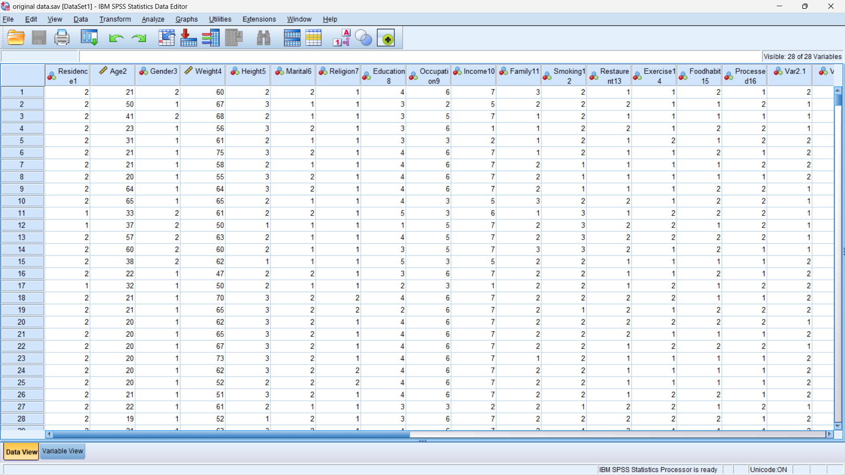

**Variable View**

